Booster Juice Set-Up
NOTE: it would be easier to create a combo menu item but combo items only generate ONE label. Follow these instructions so that TWO labels can be printed – one for the wrap and one for the smoothie. This makes delivery of items easier for the volunteers and teachers.

Prior to these steps you must set up the schedule.

Select the schedule and go to Menus.
On the menu date, click the Edit (pencil). See screen shot below.
Update the Menu Title to Booster Juice
Insert the Menu Instructions as shown.

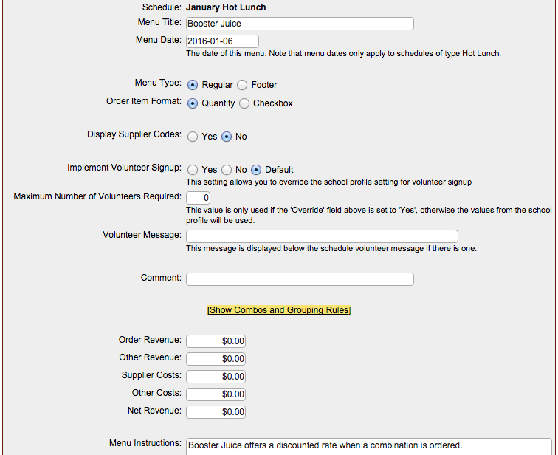

Select Show Combos and Grouping Rules
In Group B, “A” Required and “B” Mandatory – Select Yes.
Add the Maximum Quantity Message as shown.
Click Update (at the bottom of the page).
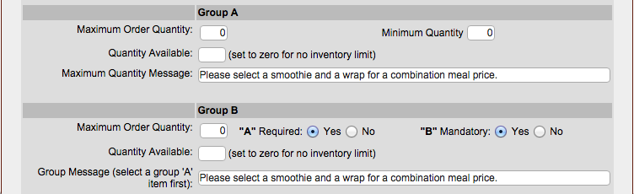

Generate Menu
On the Menu page (on the Booster Juice date) select Generate Menu from Supplier Products. Supplier – Booster Juice (4 Products) – Select Generate Menu.
Return to the Generate Menu from Supplier Products tab and choose Supplier – Booster Juice, View Products. Select the Whole Wheat Wrap.

Combination Set Up
Click Manage Menu Items (on the Booster Juice date).
The screen will look like this:
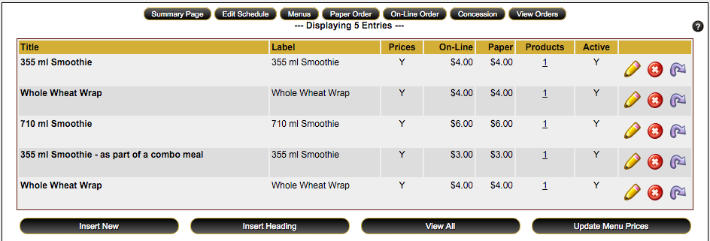

Hover your cursor at the end of the 355 ml Smoothie – as part of a combo meal and it will change to a 4 point arrow. Click and hold the item to drag it to the top. Change the order of the items as shown in the screen shot below.

Select Insert Heading from the bottom. Create the heading as shown in the screen shot. Repeat and create the second heading. Drag the heading to the correct location.

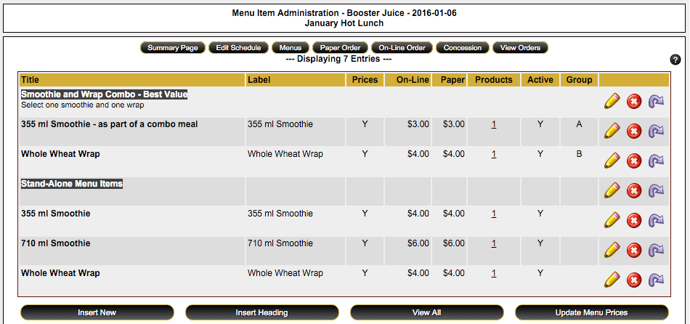

Create the combo rules

Click the Edit button on the 355 ml Smoothie – as part of a combo meal.
Change the Menu Group to A.
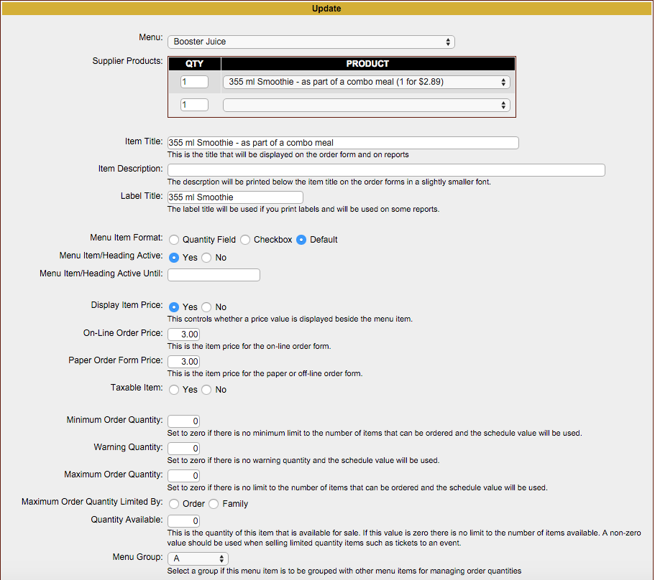

Click the Edit button on the Whole Wheat Wrap from the combo list.
Change the Menu Group to B.



