DAYSLAND HOT LUNCH - ORGANIZATIONAL MEETING FOR 2015/16
MAY 27, 2015 @ 6:15 pm

Meeting commenced in the school library with 9 parents, and Mrs Story present.
Marie Harty chaired the meeting in the absence of Coordinator Tara.
Agenda was presented and there were no additions.

FINANCIAL REPORT
- Candice presented a financial summary from current school year and also a comparison to the past three years. Net profit on food items for the year is $6230 with addition expenses of $518 for general supplies and $416 for Pay Pal fees.
- It was agreed that Beef On A Bun price to students should be increased from $3.50 to $4.00. There was little profit made this year due to the increase in beef costs.

ONLINE SYSTEMS REPORT
Amy reported that the online system was working well. She noted that the program has an option to add an additional URL that could be used by the school to collect school fees, fieldtrip fees, etc. The addition and use of this option would incur paypal fees. Amy will talk with the office staff to let them know that the option is available.

PARENT FEEDBACK / IDEAS MOVING FORWARD
- Mrs Story gave the results of a student survey that she and the high school CTS class arranged. See copy of the survey below.
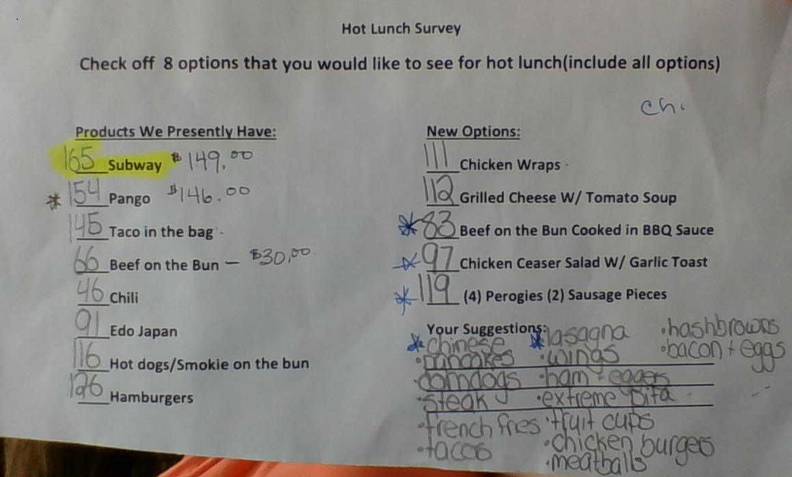
- Pauline (Milk Coordinator) brought up the option to offer Milk only on hot lunch days rather than every day. After brief discussion it was decided that the idea should be discussed at a parent council meeting. Another idea was put forward that the school could obtain a vending machine for milk and water. More info will be gathered surrounding the possibility and cost associated.
- It was unanimously agreed that while we continue canvassing for hot food sponsorship, we will discontinue offering free hot dog and smokies. Instead, sponsorship will be used to offset costs as required in order to enhance healthy menu items such as adding fresh carrots and vegies. Suggested price for hot dogs is $1.50.
COMMITTEE POSITIONS
- COORDINATOR – Tara is working full time and would like to step back. Marie volunteered to take on role as coordinator
- ONLINE SYSTEMS – Amy W will remain
- VOLUNTEERS – Person separate from overall coordinator to arrange circles and communicate with volunteers. Allison volunteered
- SPONSORSHIP – Cindy Cannady (new parent) volunteered to be the sponsor contact
- CHRISTMAS BUFFET & SPECIAL OCCASIONS – Deb Kirk will remain
At 7:00, Tracey and Candice moved over to take part in the start of parent council meeting. Mrs. Story also had to leave. The remaining people worked on reviewing 2015/16 school calendar and scheduling.
Revisions to next years’ menu are based on consideration of:
- Student Survey Results
- Mrs Story’s recommendations for choosing healthy items
- Making a Profit
- Volunteer availability
- Parent feedback to have more home cooked options rather than fast food items
- Desire to support local businesses.
- Making use of health approved cooking sites (such as CTS room and access to commercial kitchens) rather than parents cooking at home.
New Menu options that we will try to offer include: Chicken Cesar Salad & Garlic Toast, Perogies & Sausage, Possibly pancakes & sausage or sausage & eggers. The addition of these new menu items will depend on finding a supplier or availability of a willing team leader.
Adjustments to previously offered items: Beef On A Bun to include a sauce (similar to what is used in Hamburgers) or to offer pulled pork if the beef is too expensive, continue with Lasagne (but not M&M), substitute part of Edo dates with local Henry’s Chinese food, Inquire about ordering from Domino’s pizza for a change from Panago (there is no problem with current Panago supplier, but will consider other options).
Alisson will contact and work with circle leaders to confirm their availability for the dates and menu items chosen.
Meeting ended 8:40 pm.

