Hot Lunches Online Program
Instructions for Leaders

Access the website: https://daysland.hotlunches.net
User Name: leader
Password: please contact hot lunch committee for the password

As a team leader you will be e-mailed a report with details of the upcoming orders, a copy of which will also be posted in the elementary lunchroom.

Remember there is also a Help menu located in the upper right corner of the page.

Volunteer Lists:

- Orders – Manage Volunteers
- Menu Date – select the menu date
- Click Change Menu Date
- The list of volunteers for the date will be listed with their phone numbers.
- If you want to e-mail a volunteer, click their name and an e-mail box will appear.
- If you have additional volunteers to add, select their name in the User Name box and click Add Volunteer. Please only add volunteers if you have confirmation that they are willing to help on that date.
- Click Print Reports to print a copy

On the welcome screen:
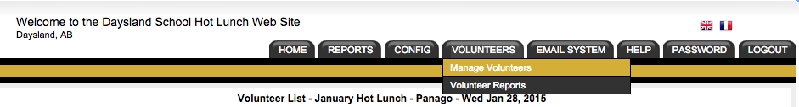

Manage Volunteers:
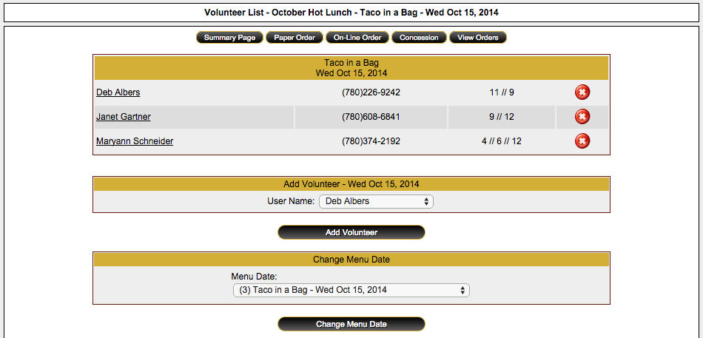
This is where user names will appear.
This is where your volunteers will display with their phone number. Their names are underlined and can be clicked to start an e-mail message.

